How to find your MAC Address

Android
1. Go to the Home screen
2. Tap Menu
3. Tap Settings
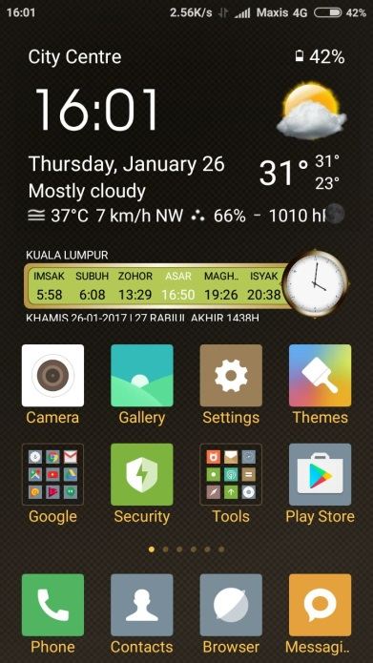
4. Tap About Phone
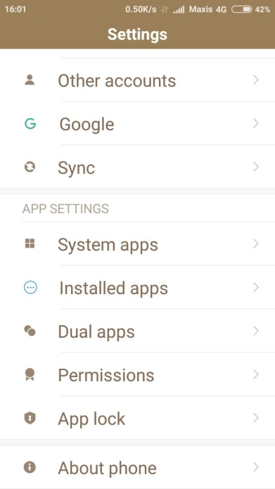

5. Tap Status
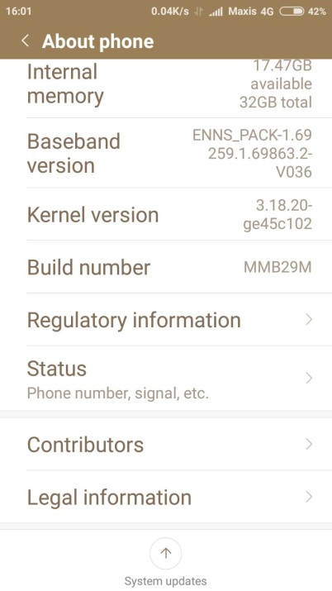
6. Scroll down to see Wi-Fi MAC address
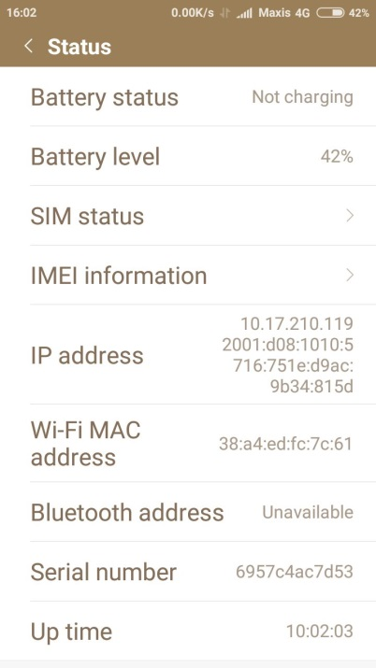

iPhone, iPad, iPod Touch
- Tap Settings
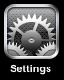

- Tap General
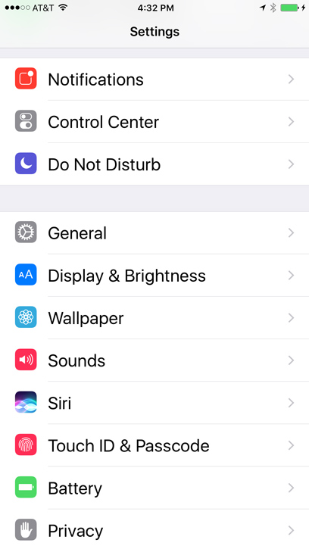

- Tap About
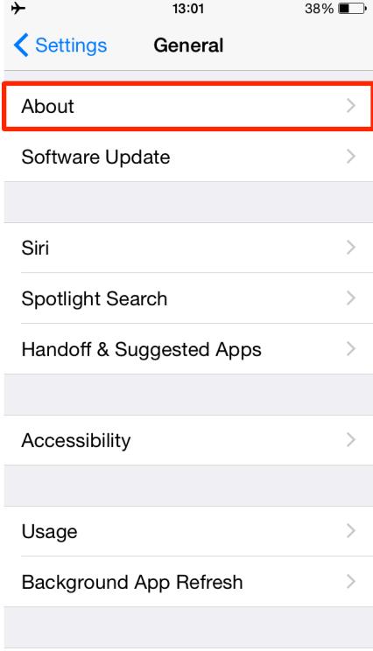

4. Scroll down to Wi-Fi Address
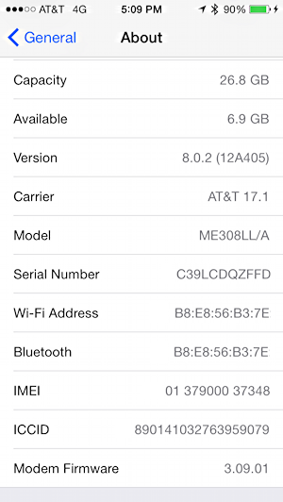

Windows-based mobile devices
- Open Settings
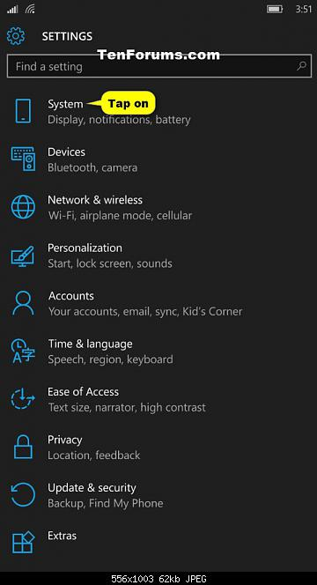

- Click Next
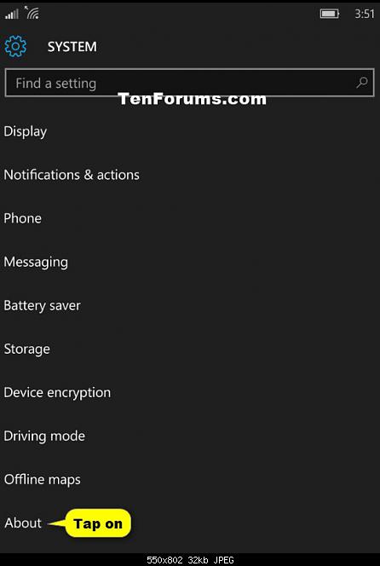

- Click About
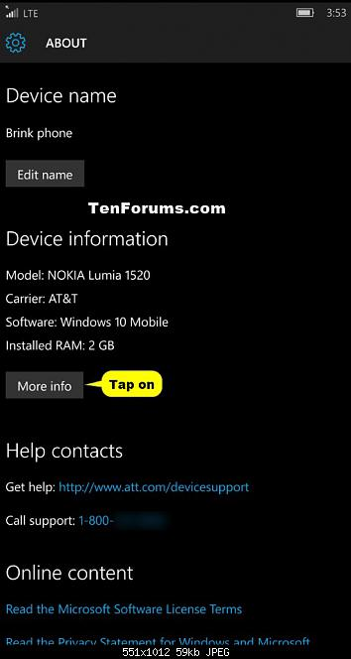

- Press more info - MAC address is on the next screen
